CHAPTER 12: INTEREST RATE FORWARDS AND OPTIONS

END-OF-CHAPTER QUESTIONS AND PROBLEMS

1. (Interest Rate Option Strategies) While the Black model is designed to price options on futures, it can be adapted to price interest rate options. The model requires the futures price, exercise price, risk-free rate, time to expiration, and volatility. When using the model to price interest rate options, the forward rate is inserted for the futures price. This rate reflects the current value of the underlying. The exercise price is just the exercise price on the interest rate option. The risk-free rate is the continuously compounded risk-free rate over the life of the option. The time to expiration is just the time to expiration of the option, and the volatility is the standard deviation of the volatility of the continuously compounded forward rate. When the option value is obtained, however, it must be discounted at the underlying forward rate to reflect the fact that the option does not pay off at its expiration, but instead, pays off at a later date. In addition, the option price must be multiplied by a factor such as days/360 because the rate produced by the model is an annual rate, then this result is multiplied by the notional amount.

2. (Structure of a Typical Interest Rate Swaption) If a swaption is exercised, it has a market value based on the present value of the payments on the swap that is created by exercise net of the present value of the payments on an otherwise equivalent swap that would be created at the going rate in the market at the time of exercise. The net difference in these two streams of payments is the market value of the swap. Accordingly, the swap can be terminated at expiration by simply having one party pay the other this net difference. Paying the market value of a stream of payments is equivalent to paying the stream of payments.

3. (Structure of a Typical Interest Rate Swaption) The two types of swaptions are payer swaptions and receiver swaptions. A swaption is an option to enter into a swap. A payer swaption is the right to enter into a swap as a fixed-rate payer and a receiver swaption is the right to enter into a swap as a fixed-rate receiver. The underlying is the rate on a specific type of swap. For example, consider a two-year payer swaption on a five-year swap on the 180-day LIBOR. It expires in two years. At expiration, the swaption will be in-the-money if the rate on a five-year swap based on 180-day LIBOR exceeds the exercise rate specified in the swaption. Because swap rates are directly related to interest rates, a payer swaption is similar to an interest rate call or cap. When an interest rate call or cap is exercised, however, it provides a payoff based on the difference between the interest rate and the exercise rate. When a payer swaption is exercised, its permits the holder to establish a swap, paying the exercise rate. Because swaps in the market can be established at the higher market rate, the value of the swaption when it is exercised is determined by the value of an annuity of length equal to the length of the underlying swap and where the annuity payments equal the difference between the market rate and the exercise rate. A receiver swaption works just the opposite and is more like an interest rate put or floor. Swaptions are, therefore, somewhat like interest rate options, but they are still different. Exercise of a swaption creates a stream of payments, as represented by the underlying swap, while exercise of a single option in cap or floor creates only a single payment. The remaining options in a cap or floor are exercised independent of each other.

4. (Structure of a Typical Interest Rate Swaption) If the bank expects it will enter into a swap to pay-floating, receive-fixed at a later date, it is exposed to the risk of falling interest rates. That is, if rates fall, the fixed rate on the swap will fall by the time the swap is initiated. To hedge this risk it might consider buying a receiver swaption. This instrument would give it the right to enter into a swap to receive a specific fixed rate (the exercise rate) and pay a floating rate. If rates fall, the swaption would give it the right to receive a fixed rate as represented by the exercise rate.

5. (Forward Swap) A forward swap is a type of forward contract and, as such, carries the obligation to enter into a swap. A swaption is an option and, as such, is the right to enter into a swap. A forward swap, like any forward contract, does not require an up-front payment whereas a swaption, like an option, does require an up-front payment. Both instruments are means of entering into swaps, but one (the swaption) has flexibility, while the other (the forward swap) does not. On the other hand, the swaption requires payment of a premium up front, while the forward swap does not.

6. (Structure and Use of a Typical FRA) In this problem, you are given that the notional amount is NA=$50,000,000, LIBOR is L=4%, the strike rate (the agreed upon rate) is X=3%, and the day count is m=90. Thus the long FRA payoff is

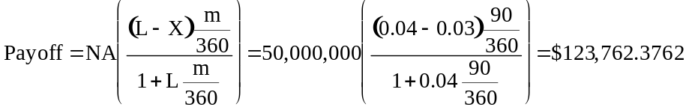

The short FRA payoff is just the negative of the long FRA payoff or –$123,762.3762.

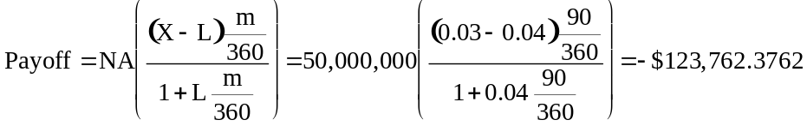

7. (Structure and Use of a Typical FRA) Like the previous problem, you are given that the notional amount is NA=$50,000,000, LIBOR is L=4%, the strike rate (the agreed upon rate) is X=3%, but the day count is m=180 rather than 90. Thus the long FRA payoff is

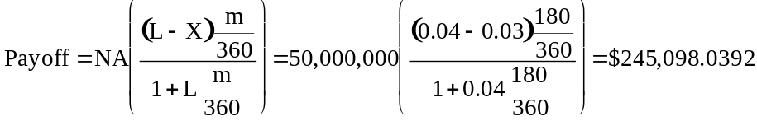

The short FRA payoff is just the negative of the long FRA payoff or –$245,098.0392.

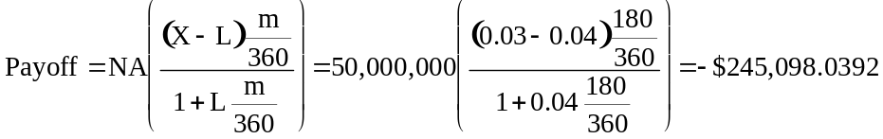

Note that from the previous problem, the long FRA payoff for the 90 day contract was $123,762.3762. Twice this value is $247,524.7524 or $2,426.7132 more than the 180 day contract. The reason for this inequality is the role day counting plays in discounting the future payoffs. Remember that discounting is non-linear. Thus, discounting for 180 days is not the same as two times the discounting of 90 days.

8. (Interest Rate Options, FRAs, and Swaps) The market quotes were as follows: Long (short) $100,000,000 interest rate cap, 90/360 day count, 4% strike rate priced at $4,950,000 ($4,925,000); Long (short) $100,000,000 interest rate floor, 90/360 day count, 4% strike rate priced at $5,000,000 ($4,975,000); and an at-market receive floating interest rate swap with identical terms of the caps and floors above is quoted at 4.0% (3.95% for receive fixed).

The arbitrage strategy, based on the equivalence between caps, floors and swaps, is to go long the cap, short the floor, and enter a receive fixed interest rate swap. The net proceeds would be –$4,950,000 for the cap, +$5,000,000 for the floor, and $0 for the swap or +50,000. In the future, the net proceeds from the swap will exactly equal, but with opposite sign, the net proceeds from the cap and floor combination.

The primary new risk introduced would be counterparty credit risk. There are numerous other risks, including liquidity risk, tax risk, accounting risk, legal risk, and so forth.

9. (Applications of FRAs) a. LIBOR = 14%

The FRA payoff will be $5,000,000(0.14 – 0.12)(90/360) = $25,000, which will be paid to the firm.

The loan interest will be $5,000,000(0.14)(90/360) = $175,000.

Thus, the net interest paid when the loan matures is $150,000. This is a rate of

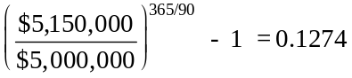

b. LIBOR = 8%

The FRA payoff will be $5,000,000(0.08 – 0.12)(90/360) = –$50,000, which means that the firm will have to pay $50,000.

The loan interest will be $5,000,000(0.08)(90/360) = $100,000.

Thus, the net interest paid when the loan matures is $150,000. This is the same outcome as in a.

10. (Pricing and Valuation of FRAs) a. The discount bond prices are as follows:

Term Rate Discount Bond Price
90 days 6.00% 1/(1 + 0.060(90/360)) = 0.9852
180 days 6.20 1/(1 + 0.062(180/360)) = 0.9699
270 day 6.30 1/(1 + 0.063(270/360)) = 0.9549
360 day 6.35 1/(1 + 0.0635(360/360)) = 0.9403

This FRA on 90-day LIBOR expires in 180 days. The rate is obtained as follows using the 270-day rate and the 180-day rate:

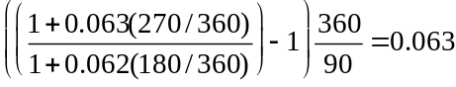

b. The value of the FRA per $1 notional amount is

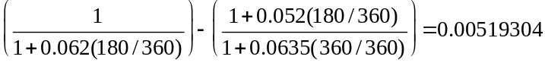

The value for a notional amount of $30 million is, therefore,

0.00519304($30,000,000) = $155,791.

11. (Interest Rate Option Strategies)
LIBOR at 6 percent
The option expires worthless. At the beginning of the loan the option premium has a future value of
32,000(1 + (0.09+0.025)(45/360)) = 32,460. The interest owed will be 10,000,000(0.085)(180/360)
= 425,000. Thus you effectively borrowed 10,000,000 – 32,460 = 9,967,540 and effectively paid back 10,000,000 + 425,000 = 10,425,000. The annualized rate is (10,425,000/9,967,540)^{365/180} – 1 = 0.0953.

LIBOR at 12 percent
The option is worth (0.12 – 0.09)(180/360)(10,000,000) = 150,000. Again, the option premium has a future value of 32,460. The interest owed will be 10,000,000(0.145)(180/360) = 725,000. Again, you borrowed 9,967,540 and effectively paid back 10,000,000 + 725,000 – 150,000 = 10,575,000. The annualized rate is (10,575,000/9,967,540)^{365/180} – 1 = 0.1275.

12. (Interest Rate Option Strategies)
LIBOR at 6.5 percent
The option is worth (0.095 – 0.065)(90/360)(25,000,000) = 187,500. The option premium has a future value of 60,000(1 + (0.095+0.01)(30/360)) = 60,525. The interest received will be 25,000,000(0.075)(90/360)
= 468,750. Thus you effectively lent 25,000,000 + 60,525 = 25,060,525 and effectively received 25,000,000
+ 468,750 + 187,500 = 25,656,250 for an annualized rate of (25,656,250/25,060,525)^{365/90} – 1 = 0.10.

LIBOR at 12.5 percent
The option expires worthless. Again, the option premium has a future value of 60,525. The interest received will be 25,000,000(0.135(90/360)) = 843,750. Thus you lent (25,000,000+60,525) = 25,060,525 and effectively received 25,000,000 + 843,750 = 25,843,750 for an annualized return of (25,843,750/25,060,525)^{365/90} – 1 = 0.1329.

13. (Interest Rate Caps, Floors, and Collars)
Interest Cap Principal Net Without Cap Net
Date Days LIBOR Due Payment Repayment Cash Flow Cash Flow
6/28 –– 10.00 –– –70,000 0 19,930,000 20,000,000
9/28 92 11.00 511,111 0 0 –511,111 –511,111
12/31 94 11.65 574,444 52,222 0 –522,222 –574,444
3/31 90 12.04 582,500 82,500 0 –500,000 –582,500
6/29 90 –– 602,000 102,000 20,000,000 –20,500,000 –20,602,000

Interest Due: On 9/28 you owe 20,000,000(0.10)(92/360) = 511,111 based on LIBOR on 6/28. All remaining figures are calculated similarly based on the number of days during the period.

Cap Payment: 70,000 paid for cap on 6/28. Cap pays off 20,000,000(0.11 – 0.10)(94/360) = 52,222 on 12/31 based on LIBOR on 9/28. Remaining figures are calculated similarly.

Principal Repayment: 20,000,000 paid on 6/29 to pay off loan.

Net Cash Flow: –Interest Due + Cap Payment – Principal Repayment. Figure on 6/28 also reflects receipt of 20,000,000.

Without Cap Net Cash Flow: –Interest Due – Principal Repayment.

The internal rate of return with the cap is

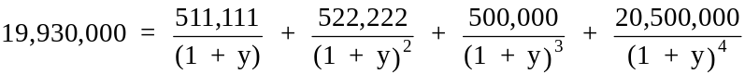

y = 0.026, annualized to (1.026)⁴ – 1 = 0.108

14. (Interest Rate Caps, Floors, and Collars)
Interest Floor Principal Net Without Floor Net
Date Days LIBOR Received Payment Repayment Cash Flow Cash Flow
4/15 –– 8.00 –– –60,000 0 –35,060,000 –35,000,000
7/16 92 7.90 715,556 0 0 715,556 715,556
10/15 91 7.70 698,931 8,847 0 707,778 698,931
1/16 93 8.10 696,208 27,125 0 723,333 696,208
4/16 90 –– 708,750 0 35,000,000 35,708,750 35,708,750

Interest Received: On 7/16, 35,000,000(0.08)(92/360) = 715,556. All remaining figures calculated similarly based on LIBOR at beginning of period and number of days in period.

Floor Payment: 60,000 paid for floor on 4/15. On 10/15 floor pays off (0.08 – 0.079)(91/360)(35,000,000) = 8,847. All remaining figures calculated similarly. Floor does not pay off on 4/16 because LIBOR on 1/16 is above 8.

Principal Repayment: 35,000,000 principal is paid off on 4/16.

Net Cash Flow: Interest Received + Floor Payment + Principal Repayment. On 4/15 also reflects payment of 35,000,000.

Without Floor Net Cash Flow: Interest Received + Principal Repayment.

The internal rate of return with the floor is

y = 0.0199, annualized to (1.0199)⁴ – 1 = 0.0821.

15. (Interest Rate Caps, Floors, and Collars)
Interest Cap Floor Principal With Collar
Date Days LIBOR Payment Payment Payment Repayment Net Cash Flow
1/15 –– 10.00 $125,000 –125,000 125,000 0 30,000,000
4/16 91 11.35 758,333 0 0 0 –758,333
7/15 90 10.20 851,250 101,250 0 0 –750,000
10/14 91 8.86 773,500 15,167 0 0 –758,333
1/15 93 –– 686,650 0 –10,850 30,000,000 –30,697,500

All calculations are done the same way as in the previous problems with one exception. Here the firm sells the floor so it receives cash up front and pays out cash whenever LIBOR is less than 9. Thus on 1/15 (at maturity) the floor pays 30,000,000(0.09 – 0.0886)(93/360) = 10,850.

The internal rate of return is

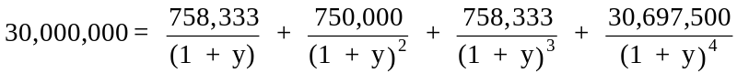

y = 0.0247, annualized to (1.0247)⁴ – 1 = 0.1025.

16. (Interest Rate Option Strategies) f₀ = 0.1322, X = 0.12, r_{c} = 0.1128, σ = 0.17, T = 45/365 = 0.1233

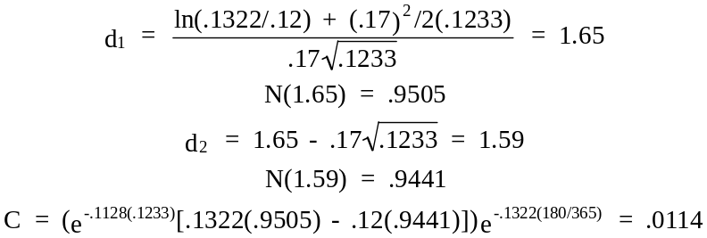

For every $1,000,000 of calls sold, this will amount to $1,000,000(0.0114)(180/360) = $5,700.

17. (Interest Rate Caps, Floors, and Collars) For the first caplet:

f₀ = 0.08, X = 0.07, r_{c} = 0.071, σ = 0.166, T = 91/365 = 0.2493

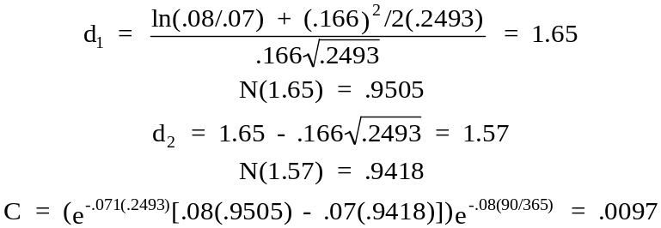

For $10,000,000 notional amount, this will amount to $10,000,000(0.0097)(90/360) = $24,250.

For the second caplet:

f₀ = 0.082, X = 0.07, r_{c} = 0.073, σ = 0.166, T = 182/365 = 0.4986

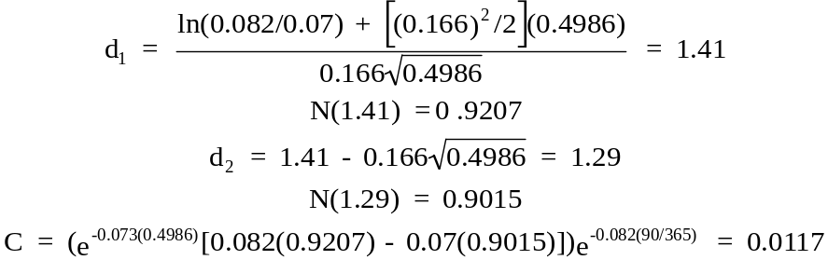

For $10,000,000 notional amount, this will amount to $10,000,000(0.0117)(90/360) = $29,250.

The total cost of the cap is, thus, $24,250 + $29,250 = $53,500.

18. (Pricing Swaptions) We must find the fixed rate on the swap. We first find the pure discount bond prices:

Term Rate Pure Discount Bond Price
360 days 0.10 1/(1 + 0.100(360/360)) = 0.9091
720 days 0.105 1/(1 + 0.105(720/360)) = 0.8264
1080 days 0.109 1/(1 + 0.109(1080/360)) = 0.7536
1440 days 0.112 1/(1 + 0.112(1440/360)) = 0.6906

The swap rate would be

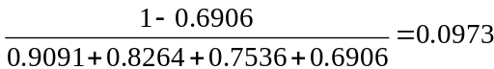

The swaption is expiring in-the-money and would be worth

(0.1175 – 0.0973)(0.9091 + 0.8264 + 0.7536 + 0.6906)$20,000,000 = $1,284,599

19. (Forward Swap) This is a forward swap, which starts in 90 days and lasts for one year with quarterly payments. To price it, we need the forward rates for the periods of day 90 to day 180, day 90 to day 270, day 90 to day 360, and day 90 to day 450. Essentially, we shall be pricing the swap 90 days ahead using forward instead of spot rates.

Day 90 to 180 forward rate

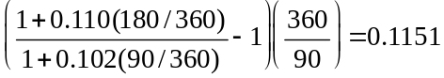

This results in a pure discount bond price of 1/(1 + 0.1151(90/360)) = 0.9720.

Day 90 to day 270 forward rate

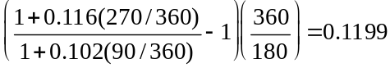

This results in a pure discount bond price of 1/(1 + .1199(180/360)) = 0.9434.

Day 90 to day 360 forward rate

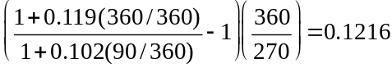

This results in a pure discount bond price of 1/(1 + 0.1216(270/360)) = 0.9164

Day 90 to day 450 forward rate

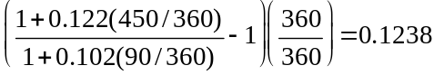

This results in a pure discount bond price of 1/(1 + 0.1238(360/360)) = 0.8898.

The forward swap rate would, therefore, be

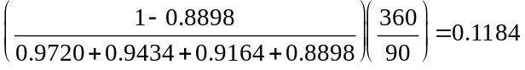

20. (Equivalence of Swaptions and Options on Bonds) A callable bond is essentially a non-callable bond plus a long call option from the firm’s perspective. The call option increases in value as interest rates fall. The firm could sell a European-style receiver swaption maturing in six years with the underlying swap maturing seven years after the option maturity. The firm would receive an immediate payment for selling the swaption. In the future, if interest rates go up, the counterparty to the swaption will not exercise the swaption and it will expire worthless. If interest rates stay down, the swaption will be exercised and the firm will be forced to enter into a pay-fixed, receive-floating interest rate swap with a seven-year maturity (the same maturity as the bonds). Remember that the firm was short the swaption so it gets the other side of the swap compared to the counterparty buying the swaption. Because rates are down, the original bonds will be called and a floating rate note could be issued to match the floating rate receipts from the swap. The net result will be a fixed rate.

Also, callable bonds have a shorter duration than non-callable bonds. When bonds are called, the duration is zero. A callable bond has some probability of being called in the future resulting in a zero duration. Selling a receiver swaption has the effect of converting a callable bond into a non-callable bond, hence it will lengthen the duration.

21. (Equivalence of Swaptions and Options on Bonds) The firm can buy a receiver swaption. This is an option that gives it the right to enter into a swap to receive a fixed rate and pay a floating rate. If rates fall sufficiently at a later date, it can exercise the swaption, thereby entering into a swap to pay a floating rate and receive a fixed rate. It would then be making floating payments and receiving fixed payments from the swap and making fixed payments on the outstanding bonds. These payments will not precisely offset, but they will partially offset and the difference will increase or decrease the effective floating rate that it is paying on the swap. As an alternative the firm could just enter into a swap to receive fixed and pay floating when and if rates fall. The swaption gives the firm the flexibility of converting to a pay-floating, receive-fixed position that can be established up front. There is no cash up-front cost to the swap, but if the firm enters into a swap when rates fall, it has to accept whatever fixed rate holds in the market at that time.

22. (Pricing and Valuation of Interest Rate Options) The continuously compounded forward rate is higher than the LIBOR-based add-on interest rate. The effect of compounding continuously results in a much higher forward rate as the spread of the 120-day rate increases. See the table below.

23. (Pricing and Valuation of Interest Rate Options) The continuously compounded forward rate is higher than the LIBOR-based add-on interest rate. The effect of compounding continuously results in a lower forward rate as the forward term increases. See the table below.

24. (Interest Rate Option Strategies) f₀ = 0.0979, X = 0.10, r_{c} = 0.0838, σ = 0.1465, T = 74/365 = 0.2027

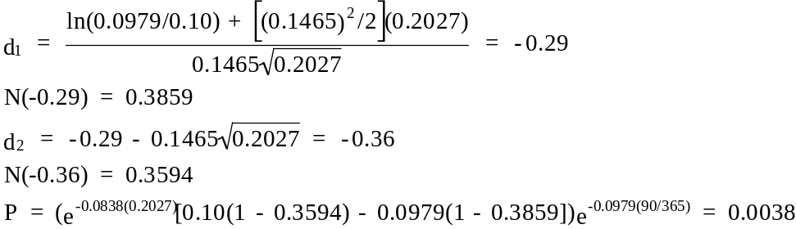

For $22,000,000 of calls sold, this will amount to $22,000,000(0.0038)(90/360) = $20,900.

25. (Interest Rate Option Strategies) Consider a call with an exercise price of x on the m-day rate L using a 360-day year. The payoff of the call will be

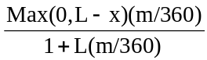

A quantity of 1 + x(m/360) puts with exercise price X = 1/(1 + x(m/360)) on a $1 zero coupon bond priced as a Eurodollar based on the m-day rate L has a total payoff of
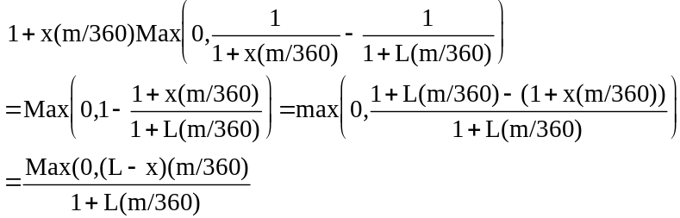

which is the payoff of the interest rate call. What this tells us is that if we know the formula for pricing one option, we can use it to price the other. Thus, a model to price a put on a bond will also price a call on an interest rate.

